**Free Recall**

# Introduction

This paper examines memory through a free recall test inspired by Ebbinghaus’ original experiments. The experiment is designed to investigate the recency and primacy effects observed by Ebbinghaus (Radvansky & Ashcraft, 2014). If such effects are present the first and last few words of each list should have a higher probability of recall. Such effects would be in line with both the Atkinson-Shiffrin multi-store model and Baddeley’s model of working memory, both of which present rehearsal as crucial for maintenance of short term memory (Radvansky & Ashcraft, 2014).

Contrary to Ebbinghaus’, this experiment does not use nonsense words allowing an investigation into the concreteness effect. This effect predicts a higher probability of recall for concrete than abstract words. The concreteness effect can be explained by both Paivio’s dual coding hypothesis and the context-availability model (Fiebach & Friederici, 2003; Radvansky & Ashcraft, 2014).

Data from this experiment is expected to support the concreteness, recency and primacy effects.

# Method

This experiment included *N* = 86 participants, all psychology students at UCPH. Age and sex differences were not considered.

## Materials

* Four lists of 20 concrete words
* Four lists of 20 abstract words
* One interference list

## Test procedure

The experimenter (E), an observer (OB), and the participant (P) were present during the study. E instructed P of the task and read aloud each list at a speed of one word per two seconds. P would then recall as many words as possible. Responses were noted by OB. For the interference list, which was randomly assigned for each P, P was asked to count backwards by three from 392 before recalling. After P had recalled as many words as possible, E waited approximately one minute before reading the next list.

Statistical analysis was carried out using SPSS.

# Results

Figure 1 shows mean probability of recall for all three lists. The recency and primacy effects are evident for both concrete and abstract lists by the inverse bell shape of the curves. The concrete lists generally follow a higher curve than the abstract lists. The recency effect seems to be missing for the interference lists.

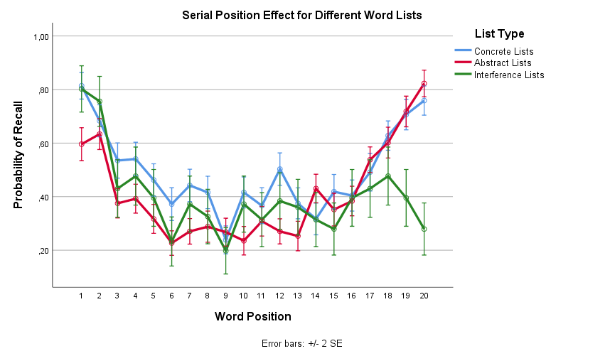

Figure 1: Graph showing recency and primacy effect and effect of word type on probability of recall

## Probability of recall depends on list type and word position

To test the validity of these observations, a repeated measures ANOVA was conducted of the effect of list type and word position on probability of recall.

The test showed significant main effects of list type, *F*(1.69, 143.86) = 25.23, *p* < .001, $η_{p}^{2}$ = .23 (Huyhn-Feldt corrected), and of word position, *F*(16.05, 1364.42) = 50.23, *p* < .001, $η_{p}^{2}$ = .37 (Huyhn-Feldt corrected). There was a significant interaction between list type and word position, *F*(28.24, 2400.28) = 7.82, *p* < .001, $η_{p}^{2}$ = .08 (Huyhn-Feldt corrected).

This confirms that the observed primacy and recency effects are significant. The effects differ between word lists, as evidenced by the interaction, supporting the supposed function of the interference lists.

Further, the results indicate that the difference between concrete and abstract lists is significant. However, such a claim cannot be made in confidence until the influence of the interference lists is controlled for.

The test was repeated without the interference lists, showing a significant main effect of list type, *F*(1, 85) = 52.67, *p* < .001, $η_{p}^{2}$ = .38, and supporting the claim that concrete words have a higher probability of recall than abstract ones (Figure 1).

To test whether this effect is present independently of word position, a repeated measures ANOVA of the effect of list type on probability of recall was conducted using only the first two words of each list.

The test showed a significant main effect, *F*(1.65, 140.49) = 13.05, *p* < .001, $η_{p}^{2}$ = .13, meaning that the concreteness effects remains relevant independently of word position, separating it from primacy and recency effects and suggesting its relevance for long term memory.

## Primacy and recency effects prove significant

Table 1 shows the average probability of recall for the first two, middle four, and last two words, displaying the primacy effect for all lists and recency effects for all but the interference lists.

|  |  |  |  |  |  |  |  |  |
| --- | --- | --- | --- | --- | --- | --- | --- | --- |
| Table 1 *Average probability of recall for each list type for select word positions.* | | | | | | | | |
|  | First Two Words | |  | Middle Four Words | |  | Last Two Words | |
| Word list | *M* | *SD* |  | *M* | *SD* |  | *M* | *SD* |
| Concrete Lists | 0.75 | (0.22) |  | 0.38 | (0.20) |  | 0.73 | (0.22) |
| Abstract Lists | 0.61 | (0.23) |  | 0.27 | (0.17) |  | 0.77 | (0.23) |
| Interference Lists | 0.78 | (0.33) |  | 0.32 | (0.30) |  | 0.34 | (0.40) |
| *Note*. Recall is shown as mean probability | | | | |  |  |  |  |

Paired samples *t*-tests showed significant differences in mean recall probability between the first two words (*M* = 0.75, *SD* = 0.22) and the middle four words (*M* = 0.38, *SD* = 0.20) in the concrete lists, *t*(85) = 15.53, *p* < .001, *d* = 1.75, and in mean recall probability between the first two words (*M* = 0.61, *SD* = 0.23) and the middle four words (*M* = 0.27, *SD* = 0.17) in the abstract lists, *t*(85) = 14.57, *p* < .001, *d* = 1.74 as well as in mean recall probability between the first two words (*M* = 0.78, *SD* = 0.33) and the middle four words (*M* = 0.32, *SD* = 0.30) in the interference lists, *t*(85) = 9.94, *p* < .001, *d* = 1.47.

There was a significant primacy effect for all three list types. The tests were then repeated for the middle four words and last two words to investigate the recency effect.

Paired samples *t*-tests showed significant differences in mean recall probability between the middle four words (*M* = 0.38, *SD* = 0.20) and the last two words (*M* = 0.73, *SD* = 0.22) in the concrete lists, *t*(85) = -11.12, *p* < .001, *d* = -1.65, and in mean recall probability between the middle four words (*M* = 0.27, *SD* = 0.17) and the last two words (*M* = 0.77, *SD* = 0.23) in the abstract lists, *t*(85) = -18.35, *p* < .001, *d* = -2.55. No significant difference was found in mean recall probability between the middle four words (*M* = 0.32, *SD* = 0.30) and the last two words (*M* = 0.34, *SD* = 0.40) in the interference lists, *t*(85) = -0.41, *p* = .68, *d* = -0.06.

There was a significant recency effect for concrete and abstract list types but none for the interference list, confirming the function of the interference task.

Notably, the concreteness effect seems less pronounced or absent for the last two words (Table 1), suggesting that concrete words are consolidated with less effort in the long term memory, while the short term memory does about equally well in holding abstract and concrete words.

## Individual data muddy the waters

Figure 2: Graph showing recency and primacy effect and effect of word type on probability of recall for FP19225

Looking at Figure 2 it is noteworthy that of the five words FP19225 recalled from the interference list, three were in the second half of the list. While the last two words, which were used for the *t*-tests above, were not recalled, this could provide some challenge to the function of the interference lists.

# Conclusion

The results of this experiment demonstrate the primacy, recency and concreteness effects and provides evidence that the working memory can be occupied and have its contents replaced through an interference task.

# References

Fiebach, C. J., & Friederici, A. D. (2003). Processing concrete words: fMRI evidence against a specific right-hemisphere involvement. *Neuropsychologia*, *42*, 62–70.

Radvansky, G. A., & Ashcraft, M. H. (2014). *Cognition* (6th ed.). Upper Saddle River: Pearson Education.